Introduction to the SPS

Gustav Pettersson January 2018

# Why the SPS?

Solar panels are used on CubeSats to generate power for the satellite to function. It is vital that the power system on the satellite works as intended to generate the most amount of power possible, and that it has been tested thoroughly. The Solar Panel Simulator (SPS) is used for this purpose. It is a piece of electronics which is designed to act precisely like a solar panel, and in which the exact characteristics of this solar panel can be controlled. It is key to recognise that solar panels do not act like a typical power supply which generates a fixed voltage (and has a maximum amount of current which may be drawn). Instead, a solar panel needs to be actively controlled. The panel presents a characteristic curve of current vs voltage; for each unique voltage applied on the panel by the satellite, a certain current will be delivered. This curve is called the IV curve and is central to understanding the workings and purpose of the SPS. A typical IV curve looks like the solid line below:

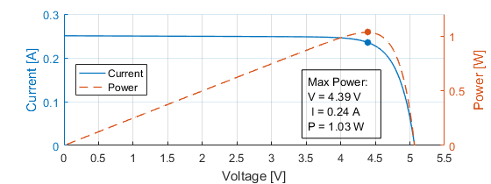

At a zero voltage, the solar panel produces a certain current (the short-circuit current). As the applied voltage increases, there will be an exponential fall in the produced current, eventually going to zero (the open-circuit voltage). Power (which is what we want!) is the product of voltage and current. Therefore, there is a balance where the voltage is “just right” and the maximum amount of power is produced! This is called the Maximum Power Point (MPP). The power is given in the same plot as the broken line, and the MPP is marked. The satellite power system will try to “chase” this voltage to generate the maximum amount of power. This is called a MPP Tracker (MPPT) and it is implemented in the Solar Array Interface (SAI) of the power system.

# What is the SPS?

The SPS is a device in which an arbitrary IV curve can be programmed to simulate any solar panel on a satellite. It works by measuring the voltage applied by the SAI and then delivering the current programmed into the Lookup Table (LUT) which gives the correct curve. It updates 1000 times per second to ensure the correct current is always given! It looks like this:

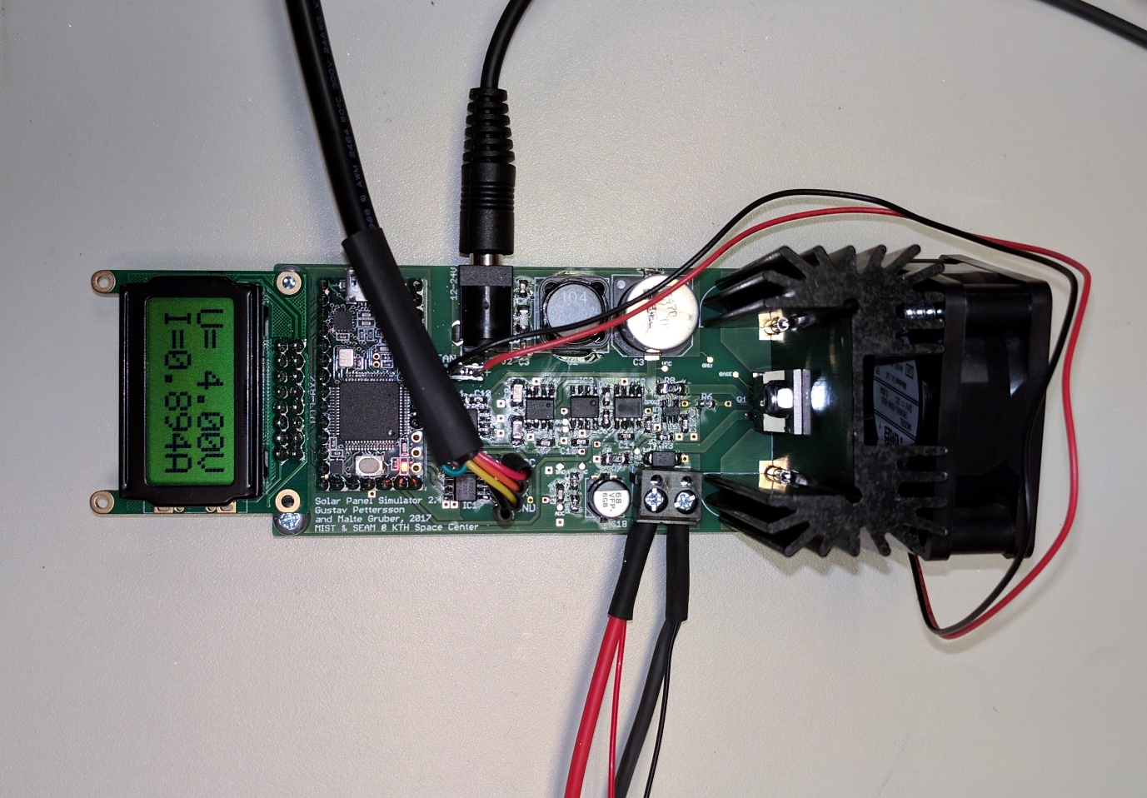

5 The fan runs directly from the power supply! 

6 The fan runs directly from the power supply! 

2

4

3

1

There are some key things to point out:

1. The power input. Use a DC power source of 12-24V which is of **high quality and isolated** from the mains power supply.
2. The power output. This side gets connected to the satellite power system as an input. **Please take care that the SPS output is disabled and that the polarity is correct!** It is highly recommended to use a connector on this wire (like the one listed in the parts list).
3. The UART connection. This is how the SPS is controlled by the computer. You need to have a UART adapter which provides 3.3-5V connected here, please care for the polarity.
4. The display. This shows what the current output voltage and current is for this SPS. It is very useful to understand how the satellite power system is working!
5. The fan. If you do not use a fan the output is limited to up to 8V 1.1A and a 12V input must be used. If you want to use up to 21V 1.1A, add a 24V fan and use a 24V power supply. If you want to use up to 8V 2.1A use a 12V fan and a 12V power supply. **The fan runs directly from the power supply!**
6. The Teensy microcontroller. This guy is the brains behind all of it. To program the Teensy use the USB port on it. **Never connect power to the SPS and the Teensy USB port at the same time.** You may kill your SPS or even your PC!

# How to use the SPS?

Now that we are acquainted, it is time to use the SPS! You will need to know some things:

1. How many inputs will you run?
2. For each input:
   1. What is the maximum voltage and current of the solar panel(s) normally connected?
   2. How will I connect the SPS: Into the harness in place of a panel, or into the power system directly?
3. Do you have an SPS on hand for each input with the correct current and voltage rating?
4. Are you ready to take full responsibility for what happens? The SPS works great for us, but we guarantee nothing. Know what you’re doing, flight hardware is expensive!

If you know these things, go to the instructions for manual control of SPSs in the folder “SPS Manual Control GUI”. Have fun!